UNIVERSITY OF DAR ES SALAAM



SCHOOL OF AQUATIC SCIENCE AND FISHERIES TECHNOLOGY

(SOAF)

DEPARTMENT OF AQUATIC SCIENCE AND FISHERIES TECHNOLOGY

AQ 339: RESEARCH PROJECT

RESEARCH PROPOSAL

STUDENT’S NAME; MADALE B VITUS

REGISTRATION NO; 2020-04-05087

TITLE; INVESTIGATING THE RELATIONSHIP BETWEEN NUTRIENTS AND CHLOROPHYLL A AT MSIMBAZI RIVER.

SUPER’S NAME; MRS NYAMISI.

**Table of contents**

List of figures i

List of abbreviations i

CHAPTER ONE 2

INTRODUCTION 2

1.1General introduction 2

1.2 Statement of Research Problem 4

1.3 Objectives of the research 5

1.3.1General objective 5

1.3.2Specific objective 5

1.4 Hypotheses 5

1.4.1 Significance of the study 5

1.5 Literature Review 6

1.5.1 Introduction 6

1.5.2 River Pollution 6

1.5.3 Nutrients 7

1.5.4Total Nitrogen: A Measure of Nutrient Enrichment 7

1.5.5 Total Phosphorus: A Measure of Nutrient Enrichment 9

1.5.6 How Nutrient loading in river affect the pristine ecosystem and human being. 9

1.5.7 Chlorophyll a; A Measure of river Productivity 10

1.5.8 Water quality indicators 11

1.5.9 Dissolved Oxygen 12

1.5.9 PH 12

CHAPTER TWO 13

MATERIALS AND METHODS 13

2.1 Study site or area 13

2.2 Sampling design and analytical methods 14

2.3Preparation of equipments prior to sampling and sample storage. 14

2.4 Sampling checklist 14

2.5 Data collection 15

2.6 Laboratory analytical methods 15

2.4 Data analysis 16

CHAPTER THREE 17

OTHER RELEVANT INFORMATION 17

3.1 Work plan or Timeframe 17

3.2 Budgeting and Financial arrangements. 18

REFERENCES 19

# List of figures

Figure 1 To show flooding at Jangwani residents and a map showing Jangwani floodplain respectively 2

Figure 2 a hypothetical watershed showing the linkages among streams, lakes and coastal zones pollution sources for nitrogen and phosphorus. 9

Figure 3 a map showing the catchment area and tributaries of Msimbazi River. 12

List of tables

Table 1 below showing sampling methodology and preservation 15

Table 2 above shows the schedule of the whole project 16

Table 3 above shows an overview of the overall costs and its distribution in the project at glance. 17

# List of abbreviations

DO-Dissolved oxygen

EC- Electric conductivity

GPS-Global Positioning System

TDS-Total dissolved solids

TSS-Total Suspended Solids

TN-Total Nitrogen

TP-Total Phosphorus

WQI-Water Quality Index

# CHAPTER ONE

# INTRODUCTION

## 1.1General introduction

Rivers are large and often winding stream which drains a landmass, carrying water down from higher areas to a lower point, ending at an ocean or in an inland sea. Rivers are now recognized as important traits in the landscape that provide numerous useful services for people, fish and wildlife. They are among the most important ecosystems on Earth and considered unique because of their hydrology and their function interact between terrestrial and aquatic ecosystems. (Smith at el., 2003).

The Msimbazi River is an intermittent river that flows across Dar es Salaam city from higher areas of rolling hills Kisarawe in the coastal region and discharges into the Indian Ocean, The River serves as an important water source and its adjoining fertile floodplain provides a good area for farming and animal grazing, but with increasing human activities and changing weather patterns, the perennial river bed has become seasonal.

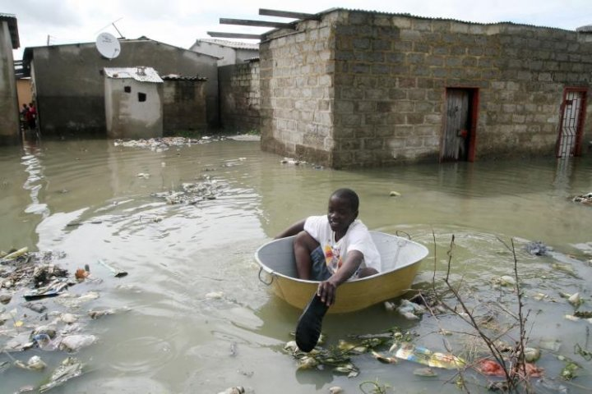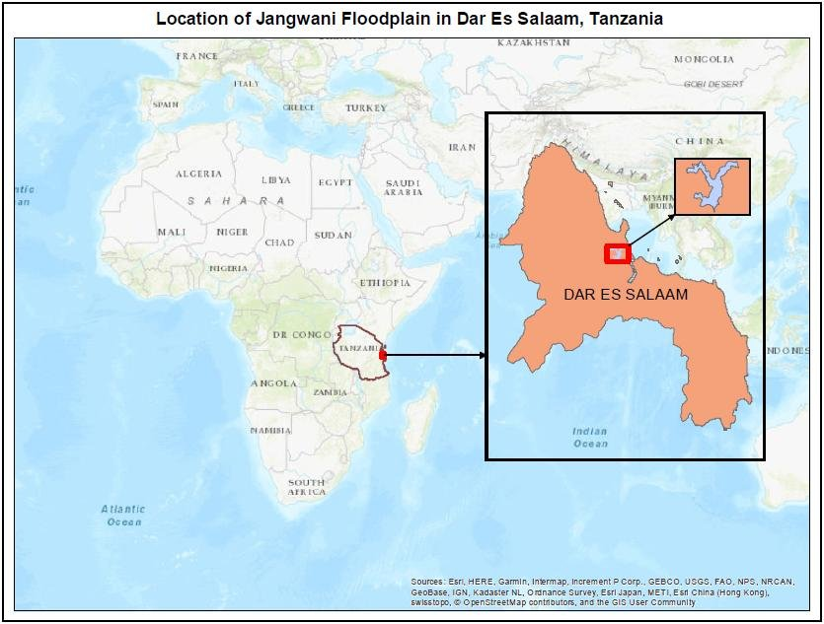

Figure 1 To show flooding at Jangwani residents and a map showing Jangwani floodplain respectively

The river flows into the largest natural salt water (Indian Ocean) in Dar es salaam -Tanzania, the water quality of the Msimbazi River has an impact and contribution for healthy of the surrounding ecosystem The river, which flows through the heart of the city, is severely degraded and under intense environmental pressure due to widespread discharge of human and industrial wastes, including raw sewage from pit latrines. Industrial pollution, untreated sewage and open defecation have made the water in the river a toxic soup infested with bacterial infection. As the globe marks World Rivers Day, health experts have cited sewage disposal into the Msimbazi River as being responsible for increased waterborne diseases, including diarrhoea, cholera and dysentery. (Ahmed at el., 2021).Snaking through the city into the Indian Ocean, the 36-kilometer (22-mile) long river is widely polluted and infested with raw sewage, animal wastes and industrial chemicals. As one of Africa’s fastest growing cities, with 70% of its 6 million inhabitants living in squalid conditions in informal settlements, the city is prone to flooding that is often causing waste-water pollution and diseases outbreaks. **Only 10% of Dar es Salaam residents connected to sewage system**’ Residents in Dar es Salaam have for decades watched in disbelief as the Msimbazi River turned into a cesspool infested with run-off emitting heavy stench. Investigations conducted by Anadolu Agency revealed high levels of heavy metal in the river run off from local industry and a waste dump near the Vingunguti area, leaking sludge into the river.

This study has established that, while there has been concern over the Msimbazi River Valley as a disaster-prone area, no legal steps or procedures have ever been taken to declare the area to be hazardous. (Calijuri at el., 2019). Because only 10% of Dar es Salaam residents are connected to the city’s sewage system, the majority use pit latrine and sceptic tanks that produce a huge volume of unsafely managed fecal sludge that often end up in this river.

Investigations further revealed a local abattoir is discharging wastes into the river causing the colour of the water to turn to brown-red. According to the country’s 2004 Environmental Management Act, man-made water pollution is prohibited “This neighbourhood is not planned, local residents do not have the means to dispose of wastes from their toilets, as a last resort they direct it to the river,” said Khalid Mazimbo, “The quality of the river’s water has sharply declined and it is no longer safe for domestic use, even for irrigation,”

## 1.2 Statement of Research Problem

The Msimbazi River flows across Dar es Salaam City from the higher areas of Kisarawe in the Coastal region and discharges into the Indian Ocean. Because of its location, the river has been an important resource for residents in the Dar es Salaam city in various ways. Additionally, the river has been abused by different sectors as a dumping site for effluent and other pollutants produced by the city. As a consequence of the high levels of pollution, Industrial pollution, untreated sewage and open defecation have made the water in the river a toxic with bacterial infection.

As the globe marks World Rivers Day, health experts have cited sewage disposal into the Msimbazi River as being responsible for increased waterborne diseases, including diarrhea, cholera and dysentery the river’s water quality has sharply decreased, and is no longer safe for consumption, domestic uses, or even irrigational uses. According to a study conducted (Wurtsbaugh at el., 2019), nutrients are increasing in catchments throughout in Tanzania. This is a cause for concern because eutrophication caused by increased nutrient loads is regarded as one   
of the most serious threats to water quality in natural aquatic ecosystems (Calijuri at el., 2008). Thus it is important to identify the sources of nutrients in catchments in order  
to manage and prevent eutrophication, nutrients and indicators of nutrient related impairment except in extreme cases nutrients alone do not impair direct beneficial uses rather they cause indirect impacts through their biostimulatory effect on algal growth, low DO and extreme pH condition among others that can impair uses examples benthic algal biomass, planktonic chlorophyll a concentrations ,diurnal DO and pH fluctuations , blue green algae (microcystis) and ionized ammonia (Ahmed at el., 2021). So there is a need to determine the relationship between nutrients concentration and chlorophyll a in the Msimbazi River because chlorophyll a is identified as a major photosynthetic pigment in a lot of phytoplankton and trophy index in aquatic system also changes with nutrients and environmental factors so to know about effective factors on chlorophyll a concentration is very important for ecosystem management and to know environmental regulation to curb nutrient loading and especially non point sources in urbanizing areas.

## 1.3 Objectives of the research

### 1.3.1General objective

The aim of this study is to explore the relationship between nutrients and chlorophyll a concentration in Msimbazi River especially total phosphorus (TP) and total nitrogen (TN)

### 1.3.2Specific objective

* To determine the concentration of total phosphate in the river
* To identify total nitrogen concentration in the river
* To examine concentration of chlorophyll a in the river
* To examine the effect of increased discharge of untreated waste water in the river.

## 1.4 Hypotheses

1. There is significantly high concentration of phosphate in the river mouth than the rest
2. There is significantly high concentration of nitrate in the lower part than the rest
3. There is significantly high chlorophyll a concentration along the river
4. Does the increase in discharge of untreated waste water in the river have any significant effects?

### 1.4.1 Significance of the study

**To the nation**

This study will contribute to the understanding and account of the current physico-chemical status of water at the selected areas /sites of Msimbazi River in Tanzania and based on the findings of this study which will be presented in this paper will aid in monitoring of immunological characteristics of aquatic ecosystem in general.

**To the community**

This study will help the individual and the entire community members to have positive minds on the recognizing the importance of the rivers to different stake holders especial those who live inside or outside the river basin through stop polluting the streams.

**To the students**

This research will be a contribution to the body of literature in the area of the relationship between nutrients and chlorophyll a on student’s academic performance, thereby constituting the empirical literature for future research in the subject area.

## 1.5 Literature Review

### 1.5.1 Introduction

Rivers are large natural stream of water emptying into an ocean, lake or other bodies of water and usually fed along its course by converging tributaries. Although they contain only 0.0001% of the total amount of water in the world at any time (Ashwani and Anish 2009). A river ecosystem includes river channels and its floodplains and form a diverse of habitats upon which countless species of aquatic animals and plants depend for survival. They provide a plethora of services for humans including a source of water for domestic and industrial uses, a source of food, a means of waste disposal, a means of transportation activities, power production, and sites for the pursuit of leisure activities (Howarth at el., 2000). Yet, they belong to the most threatened ecosystems on earth. Major threats to river ecosystems include habitat degradation, water pollution, flow modification, overexploitation, and invasion by invasive species. This is especially true for developing countries where intensification of land-use for agriculture and poor disposal of untreated waste have markedly degraded rivers and associated floodplain ecosystems. Nevertheless, a proper understanding of ecosystem functioning and biological diversity is lacking in the society so there should be some efforts that is needed to bride this knowledge gap. There for investigation on different factors that explain biodiversity and ecosystem quality in (afro) tropical river systems and associated temporary pool ecosystems in northeastern-Tanzania is important. (Baird, at el., 2012)

### 1.5.2 River Pollution

Water pollution is a growing global crisis, threatening humans and wildlife. From piles of garbage to invisible chemicals, a wide range of pollutants end up in rivers and eventually into the ocean. The loading of nutrients from waste waters and metal contaminants is high, according to the Journal of Scientific Research and Reports, the soil around Msimbazi is infested with high concentrations of lead, chromium and copper as manufacturing and processing factories discharge heavy metals and strong alkalis from textile mills steel, paint dye and food processing from both point and non point water pollution into freshwater bodies to levels exceeding their waste assimilative capacity has not only been a threat to the ecology of ecosystems. According to the country’s 2004 Environmental Management Act, man-made water pollution is prohibited and Samuel Gwamaka, the Director General of Tanzania’s environmental regulatory body – National Environmental Management Council (NEMC), warned individuals and industries about discharging effluents into the Msimbazi River because it is against the law but also to the  
resource users, specifically owing to their persistence, bio accumulative and toxic nature, even at   
Trace levels. However few studies have improved the knowledge about global riverine inputs and relatively little information have been published about African rivers environmental  
qualities of some important water resources in developing countries of the sub-Saharan region  
like Tanzania are not well investigated, probably owing to, for example, lack of modern  
analytical tools to assist in the monitoring programs, despite the contamination risks **(**Barakat, at el., 2016). In the Klamath River in California increased water temperature, excessive nutrient levels, low dissolved oxygen concentrations, high pH, potential ammonia toxicity, increased  
incidence of fish disease, an abundance of aquatic plant development, high chlorophyll-a levels  
(both planktonic and periphytic algae), and high concentrations of potentially toxigenic  
blue-green algae, particularly in the impounded reaches, lower the quality and quantity  
of suitable habitat for fish and aquatic life, and have disrupted traditional cultural uses of  
the river by resident people. These conditions contribute to the non-attainment of beneficial users. <http://www.epa.gov/waterscience/standards/about/>visits the site for more information.

### 1.5.3 Nutrients

Nutrients are chemical elements and compounds found in the environment that plants and animals need to grow and survive. For water-quality investigations, the various forms of nitrogen and phosphorus are the nutrients of interest. The forms include nitrate, nitrite, ammonia, organic nitrogen (in the form of plant material or other organic compounds) and phosphates (orthophosphate and others). Nitrate is the most common form of nitrogen and phosphates are the most common forms of phosphorus found in natural waters. High concentrations of nutrients in water bodies can potentially cause eutrophication and hypoxia. Eutrophication is a process where water bodies, such as lakes, estuaries or slow-moving streams, receive excess nutrient that stimulate excessive plant growth (algae, periphyton attached to algae and nuisance plant weeds). When a surface water body becomes nutrient rich, is biologically productive and able to support high levels of algal or macrophytic growth. Atique at el., 2019.

### 1.5.4Total Nitrogen: A Measure of Nutrient Enrichment

Nitrogen is an essential plant nutrient found in fertilizers, human and animal wastes, yard waste, and the air. About 80% of the atmosphere is nitrogen gas. Nitrogen gas diffuses into water where it can be “fixed” (converted) by blue-green algae to ammonia for algal use. Nitrogen can also enter lakes and streams as inorganic nitrogen and ammonia. Because nitrogen can enter aquatic systems in many forms, there is an abundant supply of available nitrogen in these systems. The three common forms of nitrogen are:

Nitrate (NO3-) – Nitrate is an oxidized form of dissolved nitrogen that is converted to ammonia by algae under anoxic (low or no oxygen) conditions. It is found in streams and runoff when dissolved oxygen is present, usually in the surface waters.

Ammonia (NH4+) – Ammonia is a form of dissolved nitrogen that is readily used by algae. It is the reduced form of nitrogen and is found in water where dissolved oxygen is lacking such as in a eutrophic hypolimnion. Important sources of ammonia include fertilizers and animal manure. In addition, ammonia is produced as a by-product by bacteria as dead plant and animal matter are decomposed.

Organic Nitrogen (Org N) – Organic nitrogen includes nitrogen found in plant and animal materials and may be in dissolved or particulate form.

Total nitrogen (TN) is the sum of nitrogen from nitrates, ammonia, and organic forms. We began sampling for TN in 2018. TN is determined from the same sample taken for total phosphorus (TP). TN and TP are the most common nutrient measures used by environmental managers to determine nutrient enrichment.

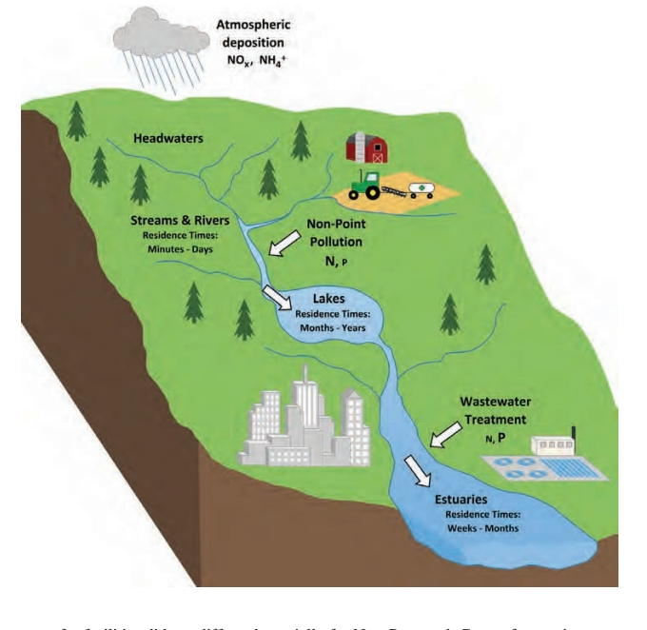

Figure 2 a hypothetical watershed showing the linkages among streams, lakes and coastal zones pollution sources for nitrogen and phosphorus.

### 1.5.5 Total Phosphorus: A Measure of Nutrient Enrichment

Phosphorus is often the key nutrient in determining the amount of phytoplankton (algae) in a lake. In comparison to other nutrients, phosphorus is usually the first element to limit biological productivity. Most of the phosphorus in lakes occurs in two forms: dissolved phosphorus and particulate phosphorus. The determination of dissolved phosphorus is a measure of the inorganic form of phosphorus available to algae. The determination of total phosphorus is a measure of all forms of phosphorus potentially available to algae.

Phosphorus enters a lake from rainfall, incoming streams, overland runoff, groundwater, and direct discharges. Phosphorus is also contributed to lakes from decomposition of organic matter and the erosion of soils. Phosphorus in the lake sediments may be released into the water under anoxic (no oxygen) conditions. Phosphorus is contributed to a lake by human activity in the watershed, direct discharge of wastes, runoff from agriculture, or poorly maintained septic systems.

Phosphorus is often the limiting nutrient in freshwater systems because it is unavailable from the atmosphere and rapidly recycled and converted to forms unavailable to algae. As the limiting nutrient, any addition of phosphorus can stimulate more algae growth.

To sample for total phosphorus, a water sample is collected every month throughout the growing season in a specially cleaned bottle and then analyzed in the laboratory.

### 1.5.6 How Nutrient loading in river affect the pristine ecosystem and human being.

Aquatic environment account for more than 80% ofthe total-land based nitrogen load and 50% of the phosphorus load (Kronvang et al., 1996). In many other developed countries, diffuse loss of nitrogen and phosphorus from the rural landscape also comprises the major cause of surface water and groundwater pollution (Ansari., el 2010). As a result of the considerable loss of nutrients, eutrophication of the open water bodies (lakes, estuarine areas, rivers and marine waters) is still one of the main global problems affecting the ecological quality and hence biodiversity of aquatic ecosystems (Ansari at el., 2010). The development and introduction of control and management programmes for combating diffuse pollution have, therefore, been given high priority during the last decade (Dodds., 2016). In Denmark and other countries, restoration of ‘naturally’ functioning river and floodplain systems is one of the means introduced to increase their ‘self purification’ potential by increasing water transit time and thereby increase the potential for sediment storage and denitrification. Nutrient criteria consist of several narrative criteria for controlling biostimulatory substances, nitrate and phosphate levels. (Lyimo et al. 2016, Kitalika et al. 2017). Although phosphorus (P) is an essential nutrient for biological productivity, it can cause Fresh water degradation when present at fairly low concentrations. Monitoring studies using Continuous sampling is crucial for documenting P dynamics in freshwater ecosystems and to reduce the risk of eutrophication. However, the presence of high TP can be of geological reason due to the nature of surrounding rocks. Also, dead animals buried in soil such as birds may contribute to elevated levels of phosphates. Additionally Water quality impacts associated with high chlorophyll in the rivers include extreme diurnal in DO and pH, Low DO conditions due to the decay of organic matter resulting from algal blooms and aesthetic impacts, by increased likelihood dominance of toxigenic blue-green algal species at higher concentration of chlorophyll a. (Dodds at el., 1998)

### 1.5.7 Chlorophyll a; A Measure of river Productivity

Chlorophyll a is the photosynthetic pigment that causes the green color in algae and plants. It is a constituent of most algae and a widely used indicator of algal biomass. Most water body authorities has a chlorophyll a standard between 15 μg/l. - 40 μg/l(micrograms per liter) for lakes, reservoirs and slow-moving waters. Light, temperature, substrate, existing water chemistry and biological communities play a role in the nuisance level of algae and macrophytes within a water body. Algal blooms and macrophytes often interfere with aesthetic and recreational uses, cause taste and odor problems in drinking water supplies and can even become toxic depending upon the type of algal growth. (Wurtsbaugh at el., 2019) Chlorophyll a.The concentration of chlorophyll α present in the water is directly related to the amount of algae living in the water. Excessive concentrations of algae give lakes an undesirable “pea soup” appearance. The water quality characteristics of a lake largely determine which types of algae will be present. Lakes with high nutrient enrichment will tend to support larger numbers of algae than lakes with low nutrient enrichment. Other factors such as water temperature, depth, pH, and alkalinity also influence the species and numbers of algae found in aquatic systems.

### 1.5.8 Water quality indicators

To determine the quality of a water body, the chemical, biological and physical conditions of a water body must be measured. Chemical measurements, biological surveys, and visual observations (physical) provide a “big picture” of what’s happening in a water body. The following is a list of indicators (physical, chemical and biological) that are often measured to assess the quality of water (Ruth at el,. 2021). These parameters are the one which is applied in the calculation of Water quality index (WQI)

1. Physical indicators; Some physical indicators of the quality of a water sample from any source include, Temperature - Electrical Conductivity - Taste - Total Suspended Solids (TSS), Turbidity - Odor - Color - Total Dissolved Solids (TDS)
2. Chemical indicators; Some chemical indicators of the quality of a water sample from any source include, pH – Biochemical Oxygen Demand (BOD) – Chemical Oxygen Demand (COD), Dissolved Oxygen (DO), Total Hardness, Phosphates, Pesticides, Nitrates, Surfactants and heavy metals.
3. Biological indicators; Some biological indicators of the quality of a water sample includes, Bacteria- (fecal coliform, Escherichia coli, Cryptosporidium, Giardia lamblia). Viruses - Fungi protozoa - Parasitic worms - Pimephales promelas (fathead minnow) -Americamysis bahia (Mysid shrimp) - [Benthic](mhtml:file://C:\Users\MDLOFFICIAL\AppData\Local\Temp\WPDNSE\%7b87AC0E20-0000-0000-0000-000000000000%7d\Application%20of%20Water%20Quality%20Index%20for%20the%20Assessment%20of%20Water%20from%20Different%20Sources%20in%20Nigeria%20_%20IntechOpen.mhtml!https://www.intechopen.com/chapters/Benthic) macroinvertebrates (Ephemeroptera or mayfly, Plecoptera or stonefly and Trichoptera or caddisfly, Sea Urchin, Mollusca (Bivalve mollusks – *Americamysis bahia* (Mysid shrimp)

Therefore Local water quality can be used to identify the sources and fates of toxic contaminants and pollutants either from ecology, geology, and [anthropogenic activities](mhtml:file://C:\Users\MDLOFFICIAL\AppData\Local\Temp\WPDNSE\%7b87AC0E20-0000-0000-0000-000000000000%7d\Application%20of%20Water%20Quality%20Index%20for%20the%20Assessment%20of%20Water%20from%20Different%20Sources%20in%20Nigeria%20_%20IntechOpen.mhtml!https://www.intechopen.com/chapters/anthropogenic%20activities) (industrial processes, runoff from agricultural farms etc) in the area. Identifying the source (s) of contamination and developing appropriate management strategies are essential to minimizing potential public health risks. Moreover, data obtained via assessment and monitoring water quality provides empirical evidence to assist health and environmental decision making. In water management practices, water quality values serve as useful and sensitive indicators of changes in the physical, chemical or biological composition of the overall water status

### 1.5.9 Dissolved Oxygen

DO determine the biological changes which occur in water in relation to living organisms aerobic or anaerobic organisms. It determines the nature extent of pollution in water since most water pollutants are oxygen demanding. The good water quality for aquatic life to flourish is normally between 4 to 6 mg/l (Howarth at el., 2000). The minimum DO levels for various rivers range between 3-4.0mg/l. Various DO objectives are based on the life cycle requirements-of aquatic species occupying warm water and marine habitat, as well as habitat of inland saline seas, and the life cycle-requirements of aquatic species occupying cold water habitat, as well as the-spawning and incubation requirements of cold water species. These are given as ambient water quality objectives applicable as instantaneous minimum requirements.

### 1.5.9 PH

Nutrient loading to a water body can contribute directly to increased ammonia  
concentrations through the addition of nitrogen to the system. The pH of the  
water column influences the concentration of un-ionized ammonia (NH3) and ammonium  
ion (NH4+). As pH increases, un-ionized ammonia concentrations increase and  
ammonium ion concentrations decrease. Nutrient concentrations alone do not impair   
uses rather combination with other factors nutrients cause indirect impacts through aquatic plant  
growth, low DO, high pH, and other related impacts. Nutrients are one of the factors in the  
impairment equation that must be present with other risk cofactors to express   
impairment. Each of these risk cofactors contributes to the degraded conditions that  
exist in the Klamath River basin today. Any watershed scale recovery plan must  
address the potential effect of the following nutrient risk cofactors. According to (Baird at el., 2012) a wider and shallower channel gains and losses heat more readily than a narrow and-deep channel. This principal is true for any stream. A stream’s width-to-depth ratio influences stream heating processes by determining the relative proportion of the wetted perimeter in contact with the atmosphere versus the streambed. Water in contact with the  
streambed exchanges heat via conduction. Conductive heat exchange with the streambed  
has the moderating influence, reducing daily temperature fluctuations.

# CHAPTER TWO

# MATERIALS AND METHODS

## 2.1 Study site or area

Msimbazi River is the second longest river in Dar es salaam originating in pugu hills and discharging into the Indian ocean .it has a length of around 32km and catchment area of 289m2, its Roughly GPS position lies between Latitude. -6.8000°, Longitude. 39.2667°.( Kizito Makoye .,2021)

Its important tributaries include rivers Sinza (Ng’ombe), Luhanga, Ubungo, and Kinyerezi. It and its tributaries have attracted valley living which historically began as land being used for agriculture before getting converted into low and medium cost residences. Where by Sinza (0km), Msimbazi River (0km), Makulamula (5.9km), Minyonyoni (5.9km) ,Mborohadi (5.9km) Ubungo (9.3km), Luhanga River (9.3km), Kimanga (9.3km), KijitoNyama (12.4km) , Mgigawa (13.1km) and Mulalakuwa (14.9km). source of information obtained from <https://travelingluck.com/Africa/Tanzania/Tanzania+%28general%29/_152975_Msimbazi+River.html>

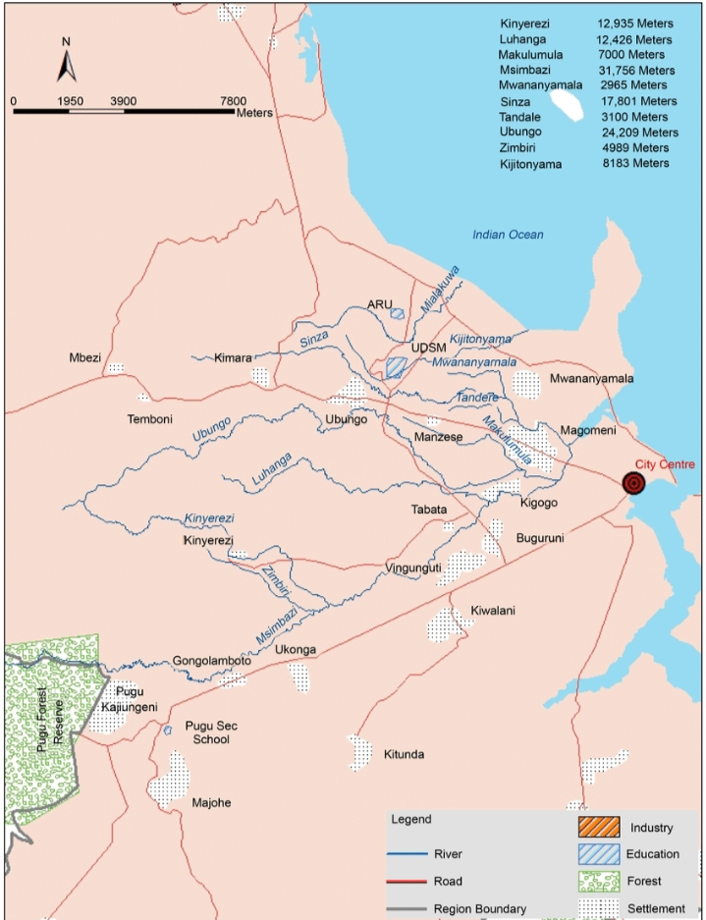

Figure 3 a map showing the catchment area and tributaries of Msimbazi River.

**2.2 Sampling design and analytical methods**

All parameters that will be covered in this study are includes: quantitative water quality parameter-physical (temperature, conductivity/salinity, turbidity, Suspended solids (TSS), and TDS) will be measured directly using multiparameter and chemical (pH, total phosphate, chlorophyll a, electric conductivity and nitrogen as well dissolved oxygen) will be done following standard methods (APHA 2012).

The most common techniques to collect water samples in river and streams will be used, manual sampling technique and location of sampling will be upstream (kisarawe), downstream (Ubungo and Jangwani ), river mouth (Salender bridge). Water samples will be collected from three stations selected for the analysis as given above.

## 2.3Preparation of equipments prior to sampling and sample storage.

Before any water sampling for nutrients and chlorophyll a, all essential apparatus including sample bottles will be sterile through washing with ultrapure water soaked in 10% Hcl overnight and then rinsed again with ultrapure water. After water sample collection, samples for nutrients and chlorophyll a analysis will be stored at 4°C I the dark room and will be analyzed after 2 days.

## 2.4 Sampling checklist

Before going out to the river equipments such as Secchi disk reading, sampling bottles, tissue paper, multiparameter/pH meter(pH, TDS, EC), and others.

Surface water samples will be collected at the selected sampling sites along the river during daylight hours, six sampling sites will be established (two sites near the inlet, two samples in the middle and two near the upper part of the river), and water samples will be collected once per month within three consecutive months ie, January, February and March. All sampling will be conducted between 10 a.m. and 4 p.m.

To measure total nitrogen/total phosphorus (TN/TP) and chlorophyll a concentration, will be taken as an integrated water sample from the river every month throughout the studying season. The sample then will be partitioned in a sample bottle and a specific volume of water will be filtered then analyzed in the laboratory for TN, TP and chlorophyll a concentration

## 2.5 Data collection

The sampling will be conducted within three months. Sampling methodology, preservation and analytical methods Samples will be taken in the lower, middle and upper part of the river of the river to represent the distribution of nutrients along the whole river. Techniques for sample collection and preservation of water will be adapted from the APHA 2012

## 2.6 Laboratory analytical methods

Persulphate method/digestion methods will be used, with the following procedures

1. 10mls of water sample will be added into the digestion bottle
2. 10mls of oxidation reagent followed by putting stoppers into the digestion bottle
3. Then autoclaving for 30minutes then loose the bottle to allow cooling

**For TP**

About 5mls of upper clear sample will be placed into the cuvette then put it in the spectrophotometer for measurement with the wavelength set at 220nm.

**For TN**

About 5mls of upper clear sample placed into the test tube, then add 0.5mls of color reagent and wait for 20minutes followed by putting the sample into the cuvette ,place it into the spectrophotometer ad adjust the wavelength at 700nm.

**For the case of chlorophyll a procedures**

1. About 150mls of water samples will be filtered in a filter unit using GF/filter membrane then the membrane is taken into a test tube containing 99% of keton with distilled water .the mixture will be left in refrigerator overnight for spectrophotometer measurement at wave ) in order to extract chlorophyll a from the membrane
2. The mixture in its test tube was removed from refrigerator and transferred to water bath for five minutes and then was removed followed by removing the filter membrane in the test tube
3. Then absorbance will be read at wavelength 665nm and 750nm without acid followed by addition of 0.1 ml of dilute hydrochloric acid solution (HCL) in each sample and reread the absorbance in the respective wavelength.

**For TSS**

Procedures; drying and labeling of each station on the filter membrane then measuring and record the weight of the membrane using a digital beam balance, a volume of 150mls of water sample will be filtered followed by removing the f. membrane using forceps and put it in the oven for 1hour then the sample will be taken to the desiccators for 10minutes. After a while remove the membrane and re weight. Therefore TSS will be obtained through calculating the difference between wet and dry membrane.

Table 1 below showing sampling methodology and preservation

|  |  |  |  |
| --- | --- | --- | --- |
| Parameters | Container | Volume (ml) | Max.preservation duration |
| pH | Plastic or grass | - | Analyze immediately |
| Temperature | Plastic or glass | 1000 | Analyze immediately |
| Do | Plastic or glass | - | Analyze immediately |
| TP | Plastic or glass | 1000 | After 2 days |
| TN | Plastic or glass | 1000 | After 2 days |
| Chl. A | Plastic or glass | 1000 | After 2 days |
| salinity(mg/l) | - | - | Analyze immediately |
| Turbidity | - | - | Analyze immediately |
| TDS | - | - | after 2 days |

## 2.4 Data analysis

Statistical software and Microsoft Excel 2007 will be used for data analysis.

For interpretation of differences in chemical and physical water quality data set, among and within the sampling stations the following statistical analysis will be applied, descriptive statistics (range, mean and standard deviation) correlation analysis will be used to evaluate the relationship between individual nutrients concentration and chlorophyll a. a non-parametric test for two independent variables (Man Whitney test) at 95% confidence level will be employed.

# CHAPTER THREE

# OTHER RELEVANT INFORMATION

## 3.1 Work plan or Timeframe

The time period for accomplishing the research requirements

|  |  |  |  |  |  |  |  |  |  |  |
| --- | --- | --- | --- | --- | --- | --- | --- | --- | --- | --- |
| Activity | sept  2022 | Nov  - | Dec  - | Jan  2023 | Feb  - | Mar  - | Apr  - | May  - | June  - | July  2023 |
| |  | | --- | | Submission of title | |  |  |  |  |  |  |  |  |  |  |
| |  | | --- | | Proposal preparation | |  |  |  |  |  |  |  |  |  |  |
| |  | | --- | | Proposal presentation and defence | |  |  |  |  |  |  |  |  |  |  |
| |  | | --- | | Proposal submission | |  |  |  |  |  |  |  |  |  |  |
| |  | | --- | | Experiment al set up | |  |  |  |  |  |  |  |  |  |  |
| |  | | --- | | Sample and data collection | |  |  |  |  |  |  |  |  |  |  |
| |  | | --- | | Laboratory analysis | |  |  |  |  |  |  |  |  |  |  |
| |  | | --- | | Data analysis | |  |  |  |  |  |  |  |  |  |  |
| |  | | --- | | Presentation of-data | |  | |  |  |  |  |  |  |  |  |  |  |
| |  | | --- | | Report writing | |  |  |  |  |  |  |  |  |  |  |
| |  | | --- | | Report submission | |  |  |  |  |  |  |  |  |  |  |

Table 2 above shows the schedule of the whole project

## 3.2 Budgeting and Financial arrangements.

|  |  |  |
| --- | --- | --- |
| Item | Description | Cost ( in TSH) |
| Exposure visit | Visiting the site and inspection for familiarization | **10,000** |
| Lab materials | Chemicals and reagents | **30,000** |
|  |  | **5,000** |
| Emergence expenses | Any less in the items | **10,000** |
| Total travel expenses |  | **20,000** |
| Stationary | Printing, binding & lamination | **15,000** |
| Total cost |  | 90,000 |

Table 3 above shows an overview of the overall costs and its distribution in the project at glance.

REFERENCES

Ahmed, W., Wu, Y., Kidwai, S., Li, X., Zhang, G., & Zhang, J. (2021). Spatial and temporal variations of nutrients and chlorophyll a in the Indus River and its deltaic creeks and coastal waters (Northwest Indian Ocean, Pakistan). *Journal of Marine Systems*, *218*, 103525

Ansari, A. A., Gill, S. S., & Khan, F. A. (2010). Eutrophication: threat to aquatic ecosystems. In Eutrophication: causes, consequences and control (pp. 143-170). Springer, Dordrecht.

Ahwani Kumar and Anish Dua. (2009) ‘Water quality index for assessment of water quality of River Ravi at Madhopur(India)’,Global Jounal of Environmental science vol.8, NO.1;49-57.Corpright©Bachudo science co.ltd. printed in Nigeria.

Atique, U. and An, K. G. (2019) ‘Reservoir water quality assessment based on chemical parameters and the chlorophyll dynamics in relation to nutrient regime’, *Polish Journal of Environmental Studies*.

Baird, R. B., Eaton, A. D., &Clesceri, L. S. (2012). Standard methods for the examination of water and wastewater (Vol. 10). E. W. Rice (Ed.). Washington, DC: American public health association

Biggs, B. J. (2000). Eutrophication of streams and rivers: dissolved nutrient-chlorophyll relationships for benthic algae. Journal of the North American Benthological Society, 19(1), 17-31

Calijuri, M. D. C., Cunha, D. G. F., Queiroz, L. A., Moccellin, J., & Miwa, A. C. P. (2008). Nutrients and chlorophyll-a concentrations in tropical rivers of Ribeira de Iguape Basin, SP, Brazil. *ActaLimnologicaBrasiliensia*, *20*(2), 131-138

.

Dodds, W. K., Jones, J. R., & Welch, E. B. (1998). Suggested classification of stream trophic state: distributions of temperate stream types by chlorophyll, total nitrogen, and phosphorus. Water research, 32(5), 1455-1462

Dodds, W. K., & Smith, V. H. (2016). Nitrogen, phosphorus, and eutrophication in streams. Inland Waters, 6(2), 155-164

Howarth, R. W., Anderson, D. M., Church, T. M., Greening, H. O. L. L. Y., Hopkinson, C. S., Huber, W. C., ... & Wiseman, W. J. (2000). Clean coastal waters: understanding and reducing the effects of nutrient pollution. National Academy of Sciences, Washington, DC

Kizito Makoye. 2021. River pollution threatens lives in Tanzania’s port city Attention focused on Msimbazi River with dangerous effluents, sewage discharged daily as globe marks World Rivers Day

Ruth Olubukola Ajoke Adelagun, Emmanuel Edet Etim and Oko Emmanuel Godwin, 2021. Application of Water Quality Index for the Assessment of Water from Different Sources in Nigeria

Smith, V. H. (2003). Eutrophication of freshwater and coastal marine ecosystems a global problem. Environmental Science and Pollution Research, 10(2), 126-139.

Wurtsbaugh, W. A., Paerl, H. W., &Dodds, W. K. (2019). Nutrients, eutrophication and harmful algal blooms along the freshwater to marine continuum. Wiley Interdisciplinary Reviews: Water, 6(5), e1373.

.

.